# Queries

1. Find the customer who has bought the most (by price) in the past year.

SELECT c.customerID, c.name, SUM(o.value) AS total_spent

FROM customer c

JOIN 訂單 o ON c.customerID = o.customerID

WHERE o.orderDate >= DATE_SUB(CURRENT_DATE(), INTERVAL 1 YEAR)

GROUP BY c.customerID, c.name

ORDER BY total_spent DESC

LIMIT 1;



1. Find the top 2 products by dollar-amount sold in the past year.

SELECT p.productID, p.name, SUM(oi.amount * o.value) AS total_sales

FROM product p

JOIN 訂單info oi ON p.productID = oi.productID

JOIN 訂單 o ON oi.orderID = o.orderID

WHERE o.orderDate >= DATE_SUB(CURRENT_DATE(), INTERVAL 1 YEAR)

GROUP BY p.productID, p.name

ORDER BY total_sales DESC

LIMIT 2;

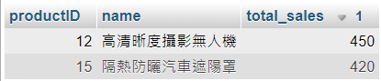

1. Find those products that are out-of-stock at every store in Kaohsiung.

SELECT p.productID, p.name

FROM product p

WHERE NOT EXISTS (

SELECT *

FROM 實體店鋪 s

WHERE s.地區 = 'Kaohsiung' AND s.storeID IN (

SELECT 實體店鋪.storeID

FROM 實體店鋪

LEFT JOIN 庫存 ON 實體店鋪.storeID = 庫存.storeID AND 庫存.product_ID = p.productID

WHERE 庫存.status = 'In Stock'

)

);

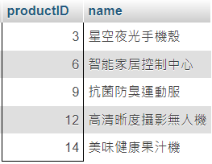

1. Find those packages that were not delivered within the promised time.

SELECT *

FROM 訂單

WHERE status = ‘expired’

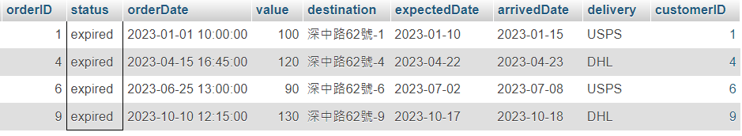

1. Assume the package shipped by USPS with tracking number 123456 is reported to have been destroyed in an accident. Find the contact information for the customer. Also, find the contents of that shipment and create a new shipment of replacement items.

Find contact information:

SELECT c.name, c.phone, c.address

FROM 訂單 o

JOIN customer c ON o.customerID = c.customerID

WHERE o.delivery = 'USPS' AND o.tracking_number = '123456'

Find contents:

SELECT p.name, i.amount

FROM `訂單info` i

JOIN `product` p ON i.productID = p.productID

WHERE i.orderID = 123456;

Create new table   
  
 code在github的mariaDB.java內